Laddr-A Smart Property Investment Application
Date:8/11/2025

Prepared by:
Group Members Details: Aaron Ninan , Aditya Jagdale , Aaryan Baadkar , Abdullah Idris Qureshi
Roll No & Name of Students: 16010123005(Aaron) ,16010123024(Aditya), 16010123010(Aaryan), 16010123015(Abdullah)
Objective:
The objective of Laddr is to build a comprehensive real estate investment platform that empowers users to make informed decisions through data-driven analytics, property comparisons, and portfolio management tools.
It integrates market analysis, property insights, and investment performance tracking into one user-friendly web application.

Work distribution (functionality wise):
Member | Responsibilities
Aaron Ninan | Backend development – API creation, authentication system (JWT), database schema design (Users & Properties collections), and deployment on Render.
Aditya Jagdale | Frontend development – Dashboard UI, analytics integration using Recharts, and API connection using Axios.
Aaryan Baadkar | Property comparison and exploration module, portfolio management, and form validation.
Abdullah Idris Qureshi | Admin dashboard design, user and property management, and responsive UI with Tailwind CSS.

Database:
- Database Type: MongoDB (Cloud – MongoDB Atlas)
- ODM Library: Mongoose
- Collections:
- Users Collection: Stores user credentials, authentication tokens, and profile details.
- Properties Collection: Contains property details such as price, ROI, amenities, risk level, and location.
- Inquiries Collection: Stores user messages and inquiries from the contact form.
- Connection:
The backend connects using the environment variable MONGODB_URI and is securely configured via the .env file.

Screenshot:
Explore Page:
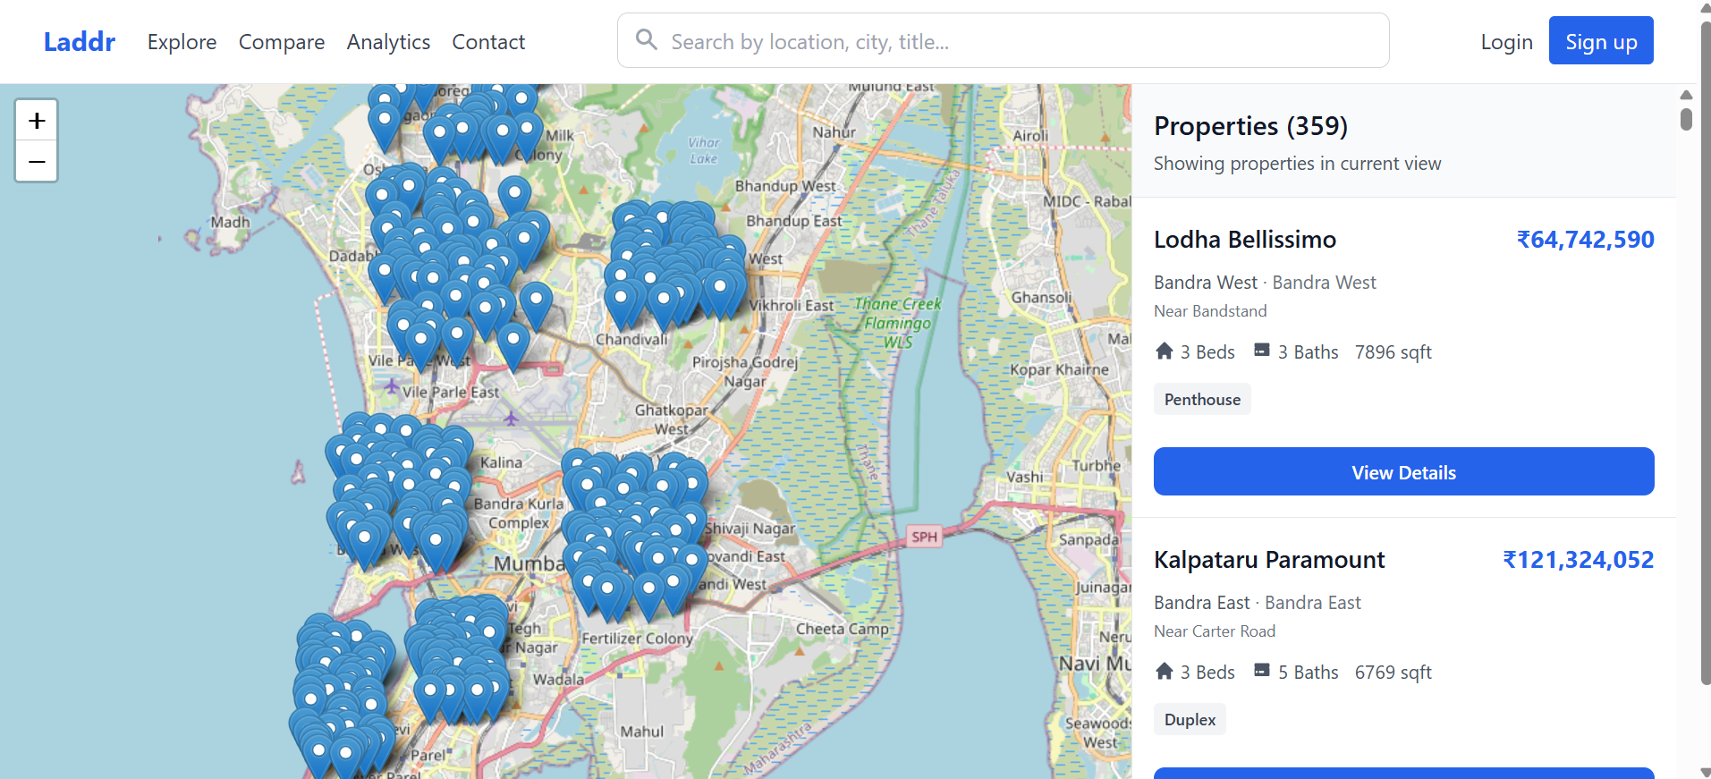
Landing Page:
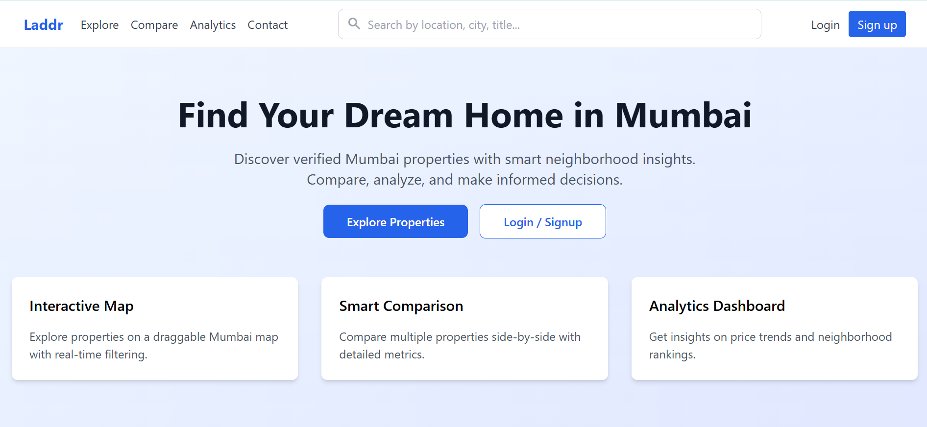
Property Comparison Page:
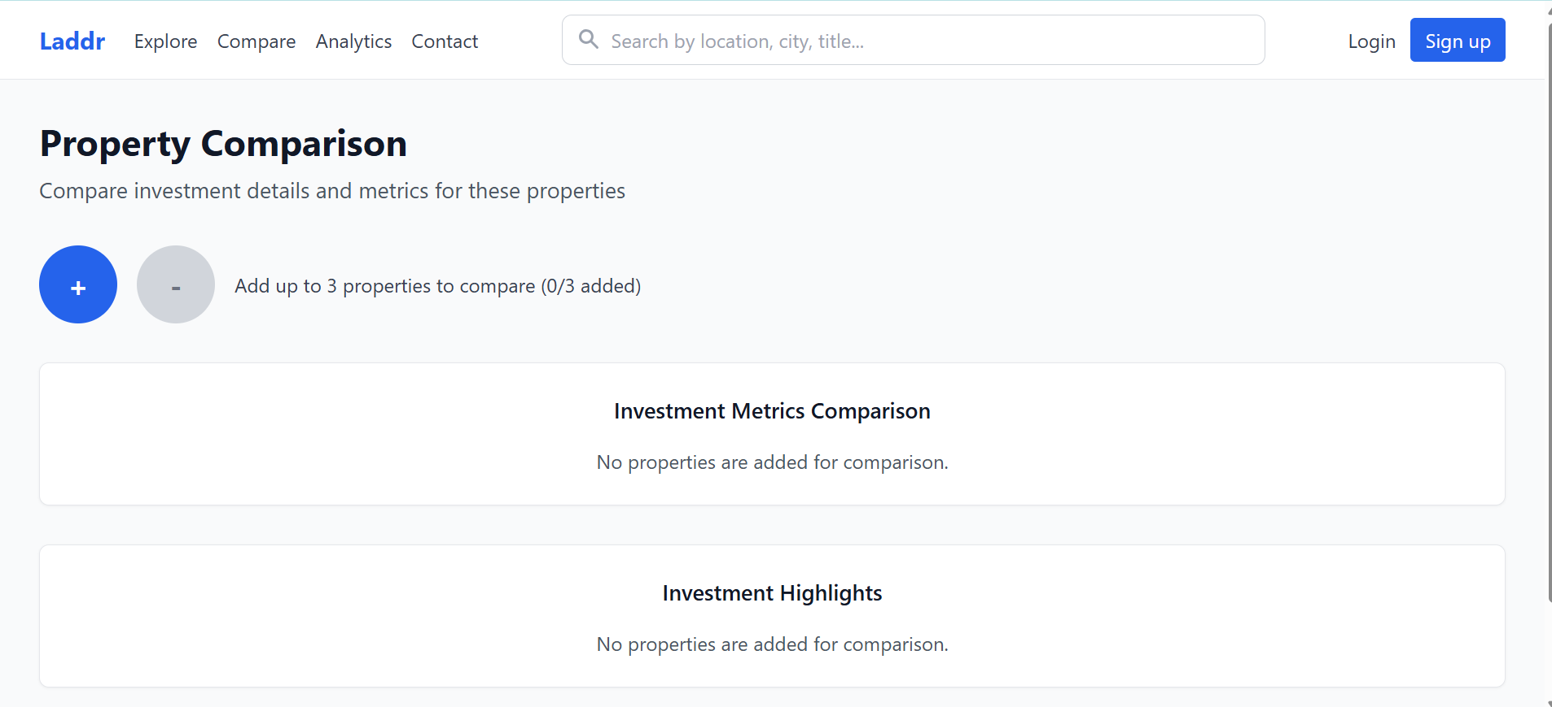
Analytics Page (Various Charts are used ):
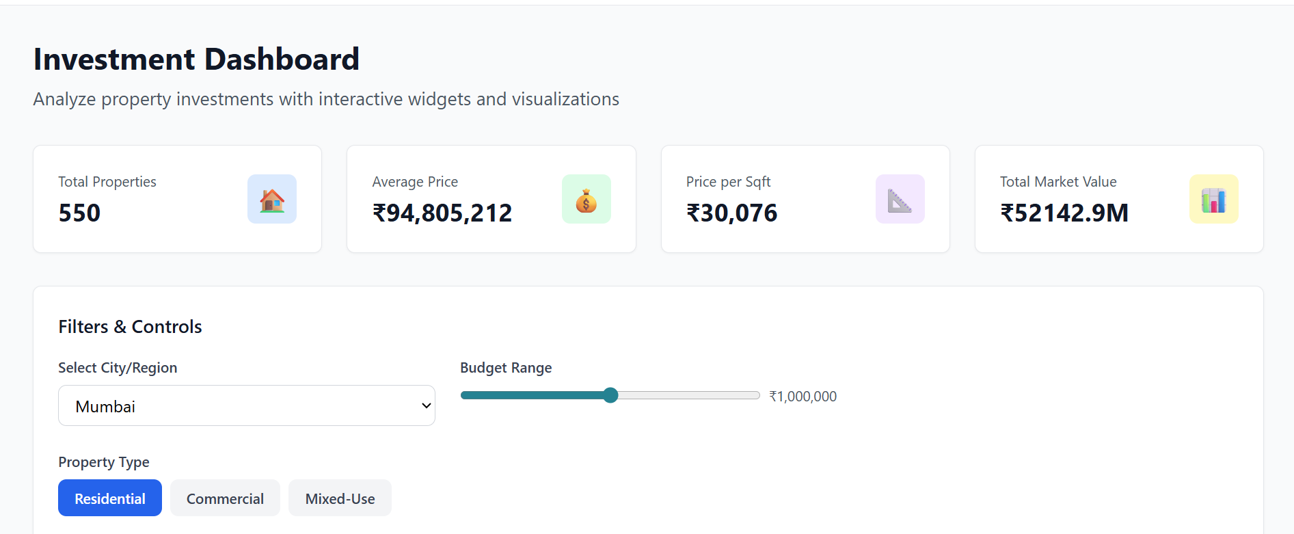

Property Detail Page:
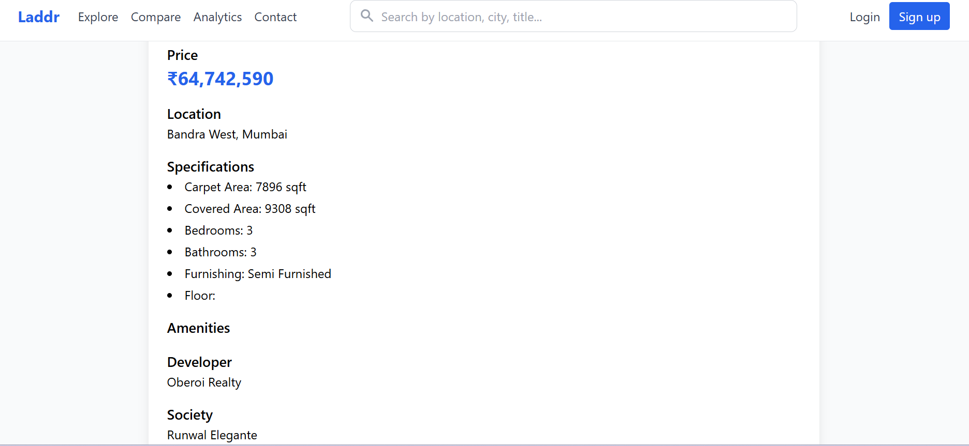

Tech Stack Used:
- FrontEnd:
- React.js (Functional Components + Hooks)
- React Router DOM (Navigation)
- Tailwind CSS (Styling)
- Recharts (Data Visualization)
- Axios (API Communication)
- Deployed on Vercel

Backend
- Node.js with Express.js
- MongoDB with Mongoose
- JWT Authentication
- bcrypt for Password Hashing
- CORS and express-validator for security and validation
- Deployed on Render

- Database:
- MongoDB Atlas

Features implemented:
User Authentication
- Secure registration and login
- JWT-based authentication
- Protected routes for logged-in users
Dashboard
- Summary metrics (ROI, Rental Yield, Risk Index)
- Interactive charts (Price Trends, ROI Forecast, Amenities Analysis)
- Market snapshot with city filters
Property Exploration
- Browse, view, and compare up to 3 properties
- Save favorite properties to portfolio
Admin Dashboard
- Manage users, properties, and inquiries
- Analytics overview
Additional Features
- Responsive design (mobile + desktop)
- Contact form and inquiry management
- Data export options
- Error handling and loading states

Technical Issues Encountered and Solved:
Issue | Solution Implemented
Complex data visualization using real-time analytics | Used Recharts for flexible and responsive chart rendering.
Handling authentication tokens securely | Implemented JWT middleware with token expiry and refresh handling.
Responsive layout inconsistencies | Used Tailwind CSS grid and flex utilities for better responsiveness.
API latency and CORS errors | Configured CORS middleware and optimized MongoDB queries.
Large frontend bundle size | Used lazy loading and code splitting in React to reduce load times.

Readme File: https://github.com/aaronninan/Laddr-new/blob/main/README.md

The Future Scope of the Project Is
🔹 Advanced property filtering and search functionality
🔹 Real-time notifications for new property listings
🔹 Portfolio analytics and detailed investment reports
🔹 AI-based property recommendations
🔹 Native mobile application (React Native)
🔹 Multi-language support for international users
🔹 Integration of payment gateways for premium features

Deployment Details
- Frontend Deployment: https://laddr-frontend-new.vercel.app
- Backend Deployment: https://laddr-backend.onrender.com
- Database: MongoDB Atlas (Cloud-hosted)
- Github Link: https://github.com/aaronninan/Laddr-new.git

